Assignment #2_Topics:Demand, Supply, and Market Equilibrium
Name:____________________________ ID:__________________________

1) Twenty years ago a stove cost $300 and a refrigerator cost $1,500. Today a stove costs $600, while a refrigerator costs $1,800. Which of the following statements is TRUE?
A) The relative price of stoves and refrigerators has not changed.
B) The relative price of a refrigerator has increased.
C) The relative price of a stove has increased.
D) The money price of a refrigerator has fallen.

2) The price of cereal rises. As a result, people have cereal for breakfast on fewer days and eat eggs instead. This behavior is an example of
A) a decrease in the quantity demanded of cereal because of the substitution effect.
B) an increase in the quantity demanded of eggs because of the income effect.
C) a decrease in the quantity supplied of cereal because of the substitution effect.
D) an increase in the quantity supplied of eggs because of the income effect.

3) When the price of an inferior good falls, the substitution effect leads to ________ in the quantity purchased and the income effect leads to ________ in the quantity purchased.
A) an increase; an increase
B) an increase; a decrease
C) a decrease; an increase
D) a decrease; a decrease

4) If the price of an Xbox player falls, then in the market for Xbox games
A) the demand curve for Xbox games shifts rightward.
B) the demand curve for Xbox games shifts leftward.
C) there is a movement downward along the demand curve for Xbox games.
D) there is a movement upward along the demand curve for Xbox games.

5) If consumers but not producers expect that the price of soda will rise in November, the
A) supply of soda in October will increase.
B) demand for soda in October will decrease.
C) demand for soda in October will increase.
D) supply of soda in October will decrease.

6) A change in which of the following alters buying plans for cars but does NOT shift the demand curve for cars?
A) a 5 percent increase in people's income
B) a 10 percent decrease in the price of car insurance
C) a 20 percent increase in the price of a car
D) an increased preference for walking rather than driving

7) If the price per bushel of apples increased from $7.00 to $8.00 because of a poor harvest, the
A) demand for apples decreases.
B) quantity of apples demanded decreases.
C) quantity of apples supplied decreases.
D) Both answers A and B are correct.
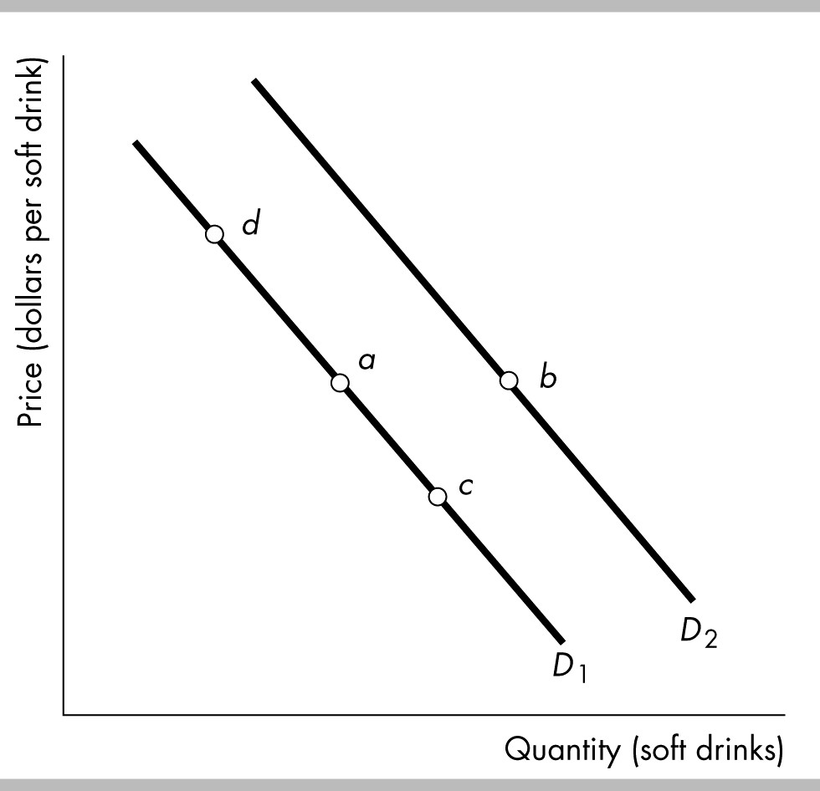
8) Consider the demand curves for soft drinks shown in the figure above. Suppose the economy is at point a. What of the following could result in a movement to point b?
A) an increase in the price of bottled water
B) a decrease in the price of bottled water
C) an increase in the opportunity cost of soft drinks
D) a decrease in the relative price of a soft drink

9) Auto workers negotiate a wage increase. How does this wage hike affect the supply of cars?
A) It decreases the supply.
B) It increase the supply.
C) It has no effect.
D) There is not enough information to tell if the change increases, decreases, or has no effect on the supply of cars.

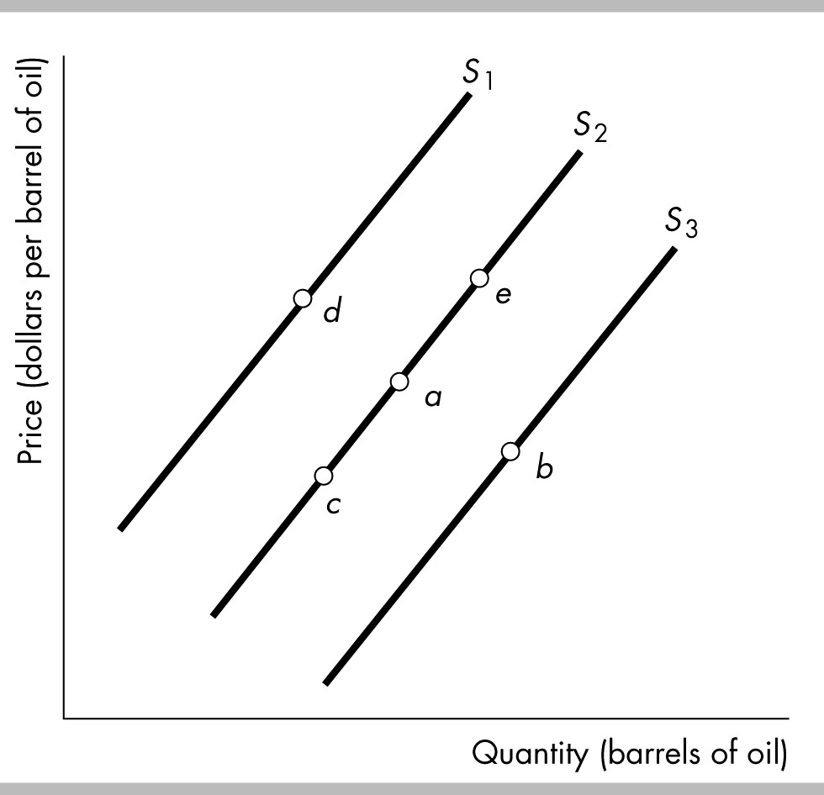

10) In the figure above, a decrease in the quantity of oil supplied but NOT a decrease in the supply of oil is shown by a movement from
A) point a to point e. B) point a to point b. C) point a to point c. D) point a to point d.

11) In the figure above, which movement could be the result of an increase in the wages paid to oil workers?
A) point a to point e B) point a to point b C) point a to point c D) point a to point d

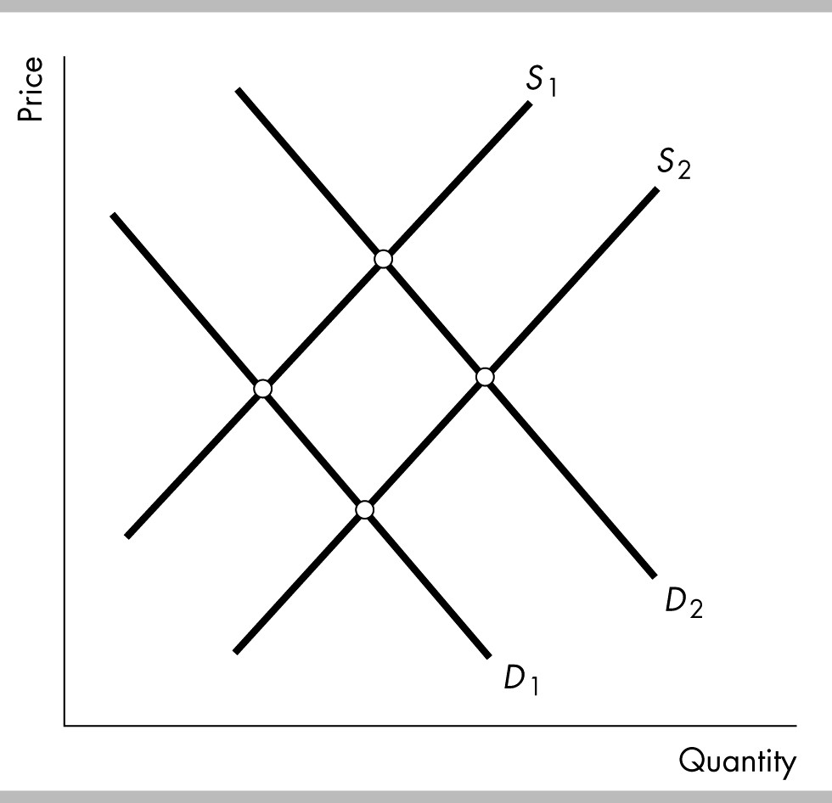
12) The above figure shows the market for french fries at fast food joints. If the price of potatoes rises and simultaneously people become concerned that french fries can cause heart attacks the
A) demand curve for french fries shifts from D2 to D1 and the supply curve of french fries does not shift.
B) demand curve for french fries shifts from D2 to D1 and the supply curve of french fries shifts from S2 to S1.
C) demand curve for french fries shifts from D2 to D1 and the supply curve of french fries shifts from S1 to S2.
D) demand curve for french fries does not shift, and the supply curve of french fries shifts from S1 to S2.

Price  (dollars per pound) | Quantity  supplied  (pounds) | Quantity  demanded  (pounds)
3 | 1 | 7
4 | 2 | 5
5 | 4 | 4
6 | 5 | 2
7 | 6 | 1
13) The above table shows the demand schedule and supply schedule for chocolate chip cookies. If the price is $4.00 per pound, there is a
A) shortage of 2 pounds of chocolate chip cookies.
B) shortage of 3 pounds of chocolate chip cookies.
C) shortage of 5 pounds of chocolate chip cookies.
D) surplus of 3 pounds of chocolate chip cookies.
Price  (dollars per disc) | Quantity demanded | Price  (dollars per disc) | Quantity  supplied
4 | 36,000 | 4 | 4,000
8 | 32,000 | 8 | 8,000
12 | 28,000 | 12 | 12,000
16 | 24,000 | 16 | 16,000
20 | 20,000 | 20 | 20,000
24 | 16,000 | 24 | 24,000
28 | 12,000 | 28 | 28,000
32 | 8,000 | 32 | 32,000
36 | 4,000 | 36 | 36,000
14) The above table gives the demand and supply schedules for Blu-ray discs. Suppose that the price of a Blu-ray disc player increases, resulting in the demand for Blu-ray discs decreasing by 8,000 units at all prices. What are the new equilibrium quantity and equilibrium price of Blu-ray discs?
A) 8,000 and $8 B) 16,000 and $16 C) 20,000 and $20 D) 28,000 and $28

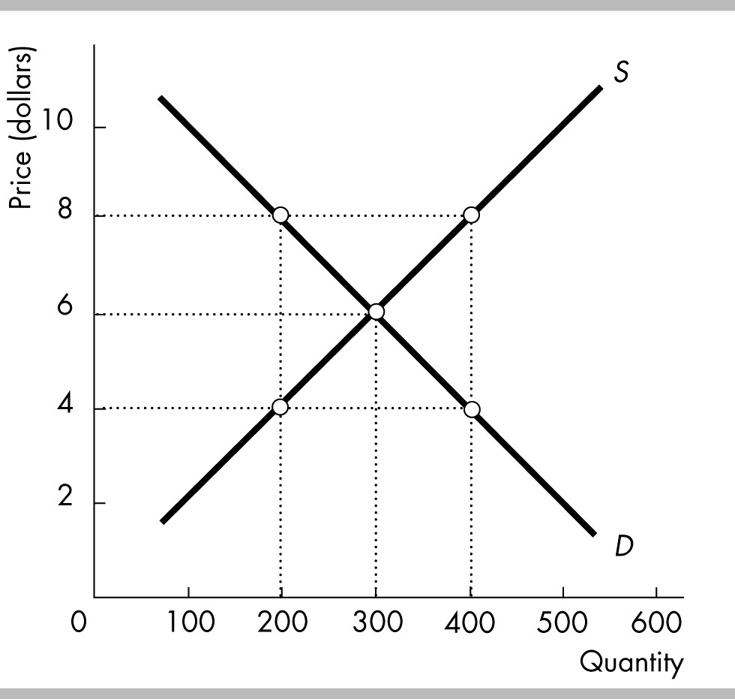
15) Based on the above figure, which of the following is TRUE?
A) At a price of $6, quantity demanded is equal to quantity supplied.
B) At a price of $4, quantity demanded is greater than quantity supplied.
C) At a price of $8, quantity demanded is less than quantity supplied.
D) All of the above answers are correct.

16) Peanut butter and jelly are complements for consumers. In 2015, the price of peanut butter increased. As a result, the ________ which lead to ________ in the price of jelly and ________ in the quantity of jelly.
A) demand for jelly; a decrease; a decrease
B) supply of jelly; a decrease; an increase
C) supply of jelly; an increase; a decrease
D) demand for jelly; an increase; an increase
17) Beef and leather belts are complements in production. If people's concern about health shifts the demand curve for beef leftward, the result in the market for leather belts will be a
A) lower equilibrium price for a leather belt because there is an increase in the supply of leather belts.
B) lower equilibrium price for a leather belt because there is a decrease in the supply of leather belts.
C) higher equilibrium price for a leather belt because there is a decrease in the supply of leather belts.
D) higher equilibrium price for a leather belt because there is an increase in the supply of leather belts.

18) "The recent hurricanes in Florida are bringing financial gain to California citrus growers. Due to extensive damage to the Florida citrus crop, California citrus products are commanding their highest prices ever." Which of the following statements best explains the economics of this quotation?
A) The supply of Florida oranges decreased, causing their price to increase, which then increased the demand for substitute California oranges.
B) The supply of Florida oranges decreased, causing the supply of California oranges to increase and the price of California oranges to rise.
C) The demand for Florida oranges decreased because of the hurricanes, causing a greater demand for California oranges and an increase in the price of California oranges.
D) The demand for Florida oranges decreased, causing their prices to rise, therefore increasing the demand for California oranges.

19) Between 2000 and 2015, the price of a PC fell and the quantity of PCs sold increased. Which of the explanations below is consistent with these facts?
A) The demand for PCs increased by more then the supply of PCs increased.
B) The supply of PCs increased by more than the demand for PCs increased.
C) The demand for PCs decreased by more than the supply of PCs increased.
D) Both the supply of PCs and the demand for PCs decreased.

20) In 2014, the price of peanuts was rising, which lead peanut butter sellers and peanut butter buyers to expect the price of peanut butter would rise in the future. Consequently, in the current market for peanut butter there was ________ which resulted in a ________ in the price of peanut butter and ________ in the quantity of peanut butter.
A) a decrease in supply of peanut butter and an increase in demand for peanut butter; rise; an increase, decrease or possibly no change
B) a decrease in supply of peanut butter and a decrease in demand for peanut butter; rise, fall, or possibly no change; a decrease
C) an increase in supply of peanut butter and a decrease in demand for peanut butter; fall; an increase, decrease or possibly no change
D) a decrease in supply of peanut butter and an increase in demand for peanut butter; fall; an increase, decrease or possibly no change
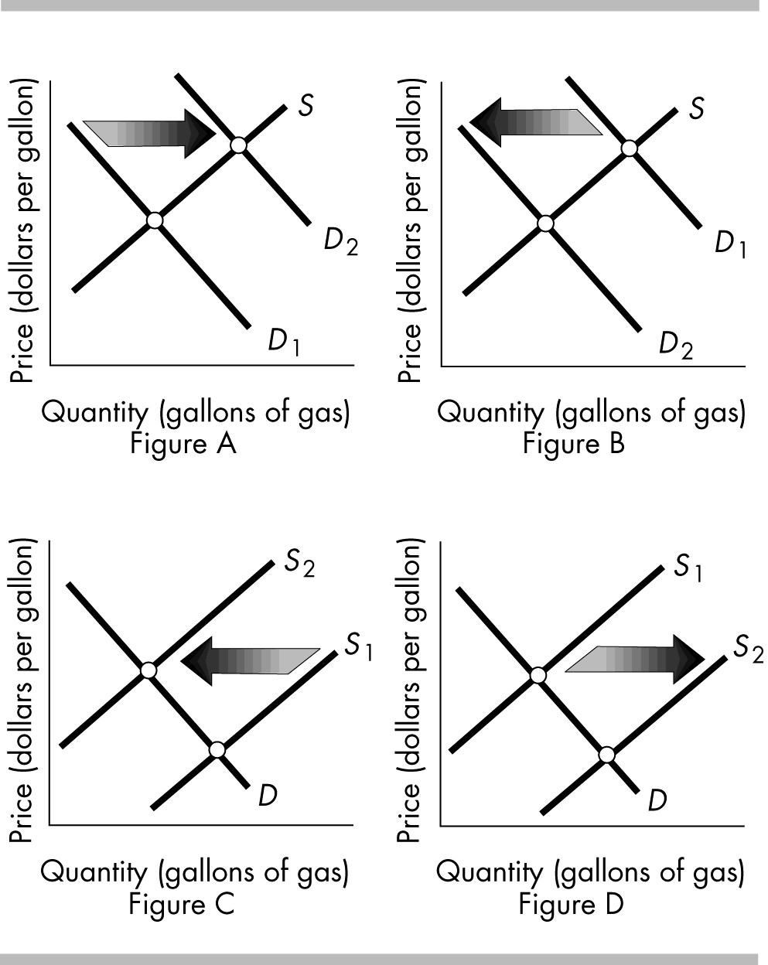
21) The above figures show the market for gasoline. Which figure(s) shows the effect of a decision by the OPEC countries in the Middle East to export less oil to the rest of the world?
A) Figure B B) Figure C C) Figure D D) Figures B and C

22) The above figures show the market for gasoline. Which figure(s) shows the effect of a new U.S. tax on oil that suppliers must pay?
A) Figures A and C B) Figures B and D C) Figure A only D) Figure C only
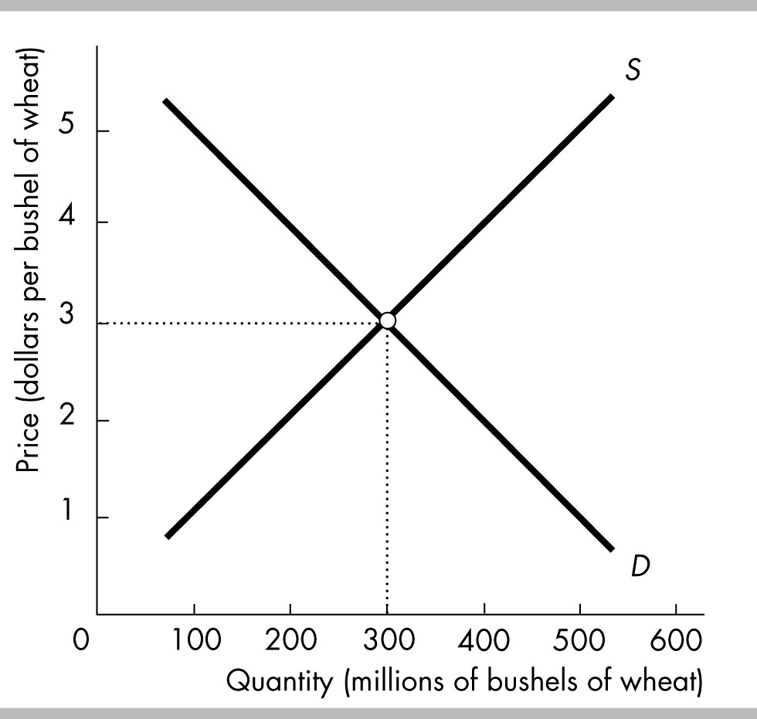
23) In the figure, the equilibrium price is initially $3 per bushel of wheat. If suppliers come to expect that the price of a bushel of wheat will rise in the future, but buyers do not, the current equilibrium price will
A) rise. B) not change. C) fall.
D) Perhaps rise, fall, or stay the same, depending on whether there are more demanders or suppliers in the market.
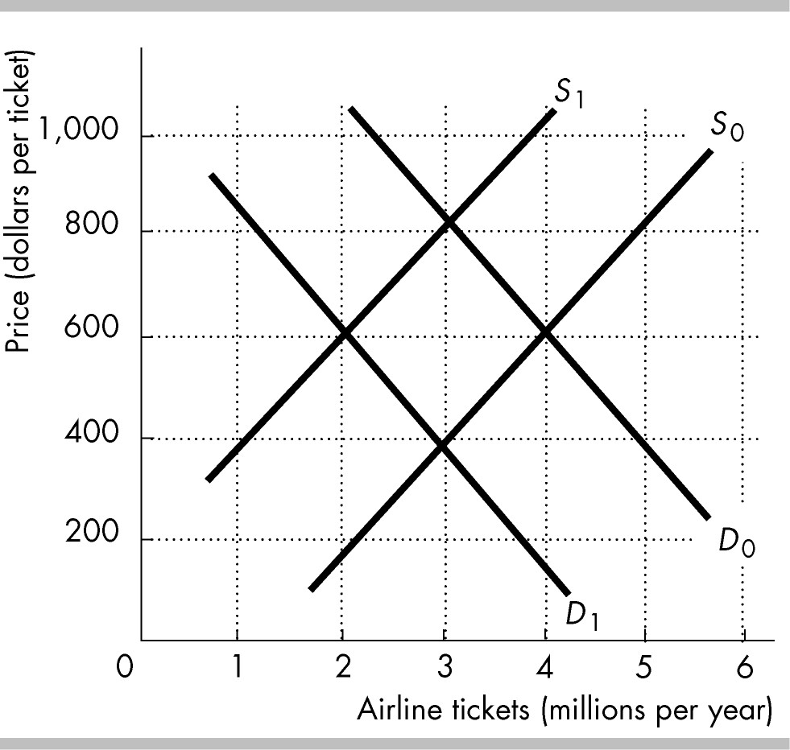
24) The figure above shows the market for airline tickets. If airline tickets are a normal good, then the recession in 2008 that caused people's incomes to decrease lead to a shift from
A) D0 to D1.
B) D1 to D0.
C) S0 to S1.
D) S1 to S0.

25) General Electric (GE) produces wind turbines that generate wind power. Over the past 10 years, the advances in technology used to produce wind turbines has resulted in
A) a movement up along the supply curve for wind-generated power.
B) a rightward shift in the supply curve for wind-generated power.
C) a decrease in the supply of wind-generated power.
D) GE increasing the quantity supplied of wind turbines.

